Holy Eucharist Rite II: The Ministry of the Word

Prelude Music
Processional Hymn #414…………….“God, My King, Thy might Confessing”

The service is followed in the Book of Common Prayer, page numbers are indicated below

Opening Sentence………………………………………p. 355
Gloria in Excelsis: “Glory to God”………………….… S280
Opening Collect………………………….……. bulletin insert

Welcome, children! At this time, children proceed to the Hall with teachers for Sunday School, and will return at the Peace.

Old Testament Reading…………………..……. bulletin insert
Psalm…………………………………………..bulletin insert
New Testament Reading……………….… …… bulletin insert

Celtic Alleluia (Sung before and after the Gospel is read)
Gospel ……….. (All stand)…..…………….…. bulletin insert

Sermon:……………………....……...........Rev. Mary Trainor

Nicene Creed…………………………………… .. …p. 358

Prayers of the People…………………. ….. p. 383(Form I)

Those in need of our prayers: For healing: Jan, Bernie, Dan, Adeline, Bruce, Pam, Connie, Frances, Dave, Tony; Aaron, Ken, and all those deployed. Diocesan Cycle of Prayer: Religious Orders, especially Sisters of the Holy Nativity

Priest adds a closing collect (prayer)

Confession …………….….....................................p. 360

Priest pronounces absolution of sins

The Peace - please greet each other in the name of Christ

Children's Sermon: A brief bible message to our children

Offertory Hymn - #401.. "The God of Abraham Praise"

"Praise God from whom all blessings flow"...Hymnal #380 v 3

The Great Thanksgiving
Eucharistic Prayer…Form B………………………….p. 367

Sanctus -“Holy, Holy, Holy”……. …………Hymnal # S130

All baptized Christians are invited to receive Holy Communion.

Post Communion: .... Insert ……"Spirit Song"
Concluding Prayer: ……………..…..………………..p. 365

Blessing

Recessional Hymn ..Supplementary Hymnal #13...."Blessed Assurance"

Dismissal, Announcements and Postlude

+++++++++++++++++++++++++++++++++++++++++++
If you are visiting today, welcome! Please see the pews for a visitor information on St. John's. If you have questions, Pastor Mary is happy to answer after the service.

TODAY:
Coffee Hour and Fellowship in the Hall immediately after the service. Yummy treats too.

The November St. John's Newsletter is now available. If you did not receive it on email, please take a printed copy from the table in the Hall.

This Week at St. John's:
Wed, Nov. 13 : 11 AM or 6:30 PM, The Wednesday Discussion Group, in Hall on Luke

Upcoming Events:
Nov. 20: 8:30 AM Prayer chain breakfast (for those who are called to the ministry of intercessory prayer)
Nov. 26: Community Dinner at Presbyterian Church
Nov. 27: 7 PM, Shawano Ecumenical Thanksgiving Service, Sacred Heart Parish
Dec. 1: Advent Quiet Retreat (after mass)

Announcements
Congratulations to the winners of our outreach fund raiser to provide chickens to needy overseas: Johnny Kerry and Lee Hafner! Winners won gift baskets.
Thanks, Kristi, for coordinating this worthwhile effort.

Pastor Mary is now the Dean of the Green Bay Deanery in our Diocese (a three year appointment). She was commissioned for this role Oct 18 in the Cathedral. As Dean she coordinates clergy gatherings, serves on the Executive Council, and meets with the other two deans advising the Bishop.

Our new bishop-elect is the Rev. Matthew Gunter from Illinois. In this time of transition, before the new bishop's consecration on April 26, the Standing Committee is the governing body for the Diocese.

Help yourself to useful resources in the Hall provided by our Health Ministry representative, Nancy Clasen!

Help those in need: bring non-perishable (canned or dried goods) foods to church and place them in the basket near the Church entrance; food is delivered to the Shawano Food Pantry (check dates on food). Also bring cleaning supplies and toiletry items for those at the Shawano Domestic Abuse Shelter; place in marked bins.

Take the time to thank our organist, Ted Myers, for his wonderful playing each Sunday. We are so fortunate to have Ted share his abundant musical talent with us each Sunday, as he leads us as we sing and praise the Lord.

PICK UP IN THE RACK IN THE HALL:
- flyers about St. John's - newsletters
- tracts that help with life's issues - sermon (copy)

St John’s staff:
Vicar- The Rev. Mary S. Trainor; Organist – Ted Myers
Bishop’s Committee: Senior Warden - Ron Stezenski; Jr. Warden- Art Frieberg; Marlene Brown, Nancy Clasen, Joe Keberlein, Wendy Hafner, LouAnne Zander; Treasurer - Sue Sazama; Clerk – Lois Renner; Youth Liaison, Ted Myers.

The Twenty-Fifth Sunday after Pentecost
November 10, 2013

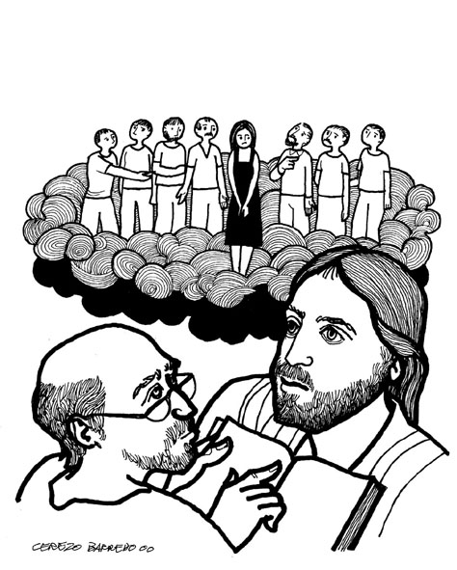
“He is God not of the dead, but of the living; for to him all of
them are alive.

St. John’s Episcopal Church

141 South Smalley St., Shawano, WI

http://www.shawanoepiscopal.org

The Rev. Mary S. Trainor, Vicar

Church Phone 715-526-3686

Vicar’s Phone 715-252-4816

pastormaryt@gmail.com
www.marytrainorblogspot.com

